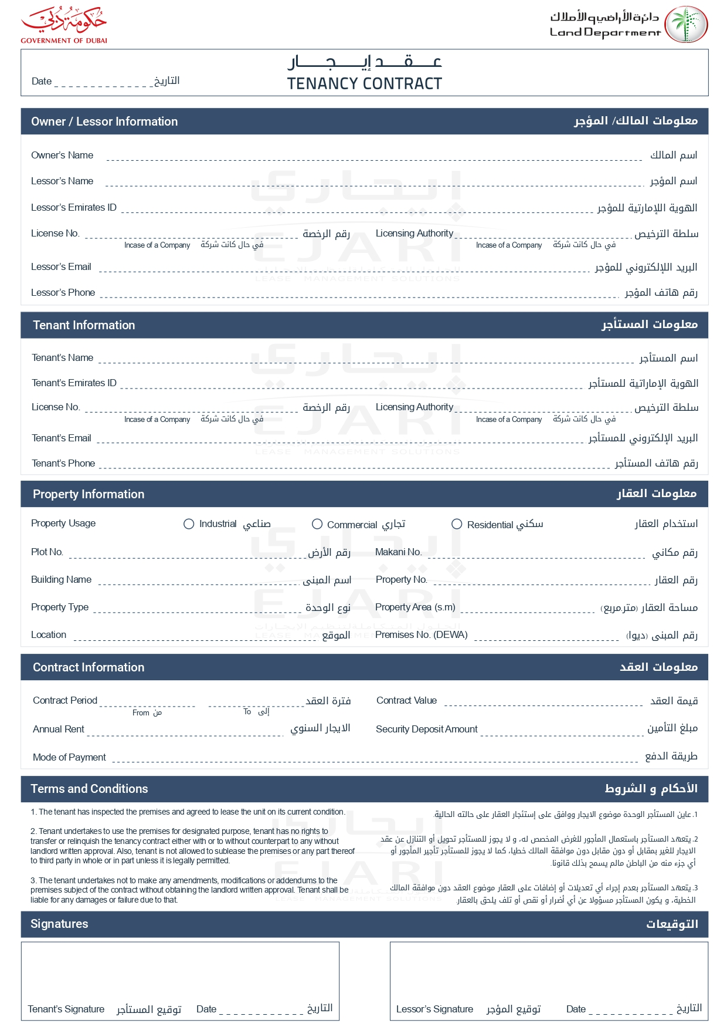

2025-04-11

John Smith

John Smith

john.smith@example.com

+971501234567

David Wilson

david.w@example.com

+971504567890

✓

G-102

Green Villa

1,300.00

GV001

22,000.00 EGP

2025-08-11

2025-04-11

1,000.00 EGP

22,000.00 EGP

Weekly

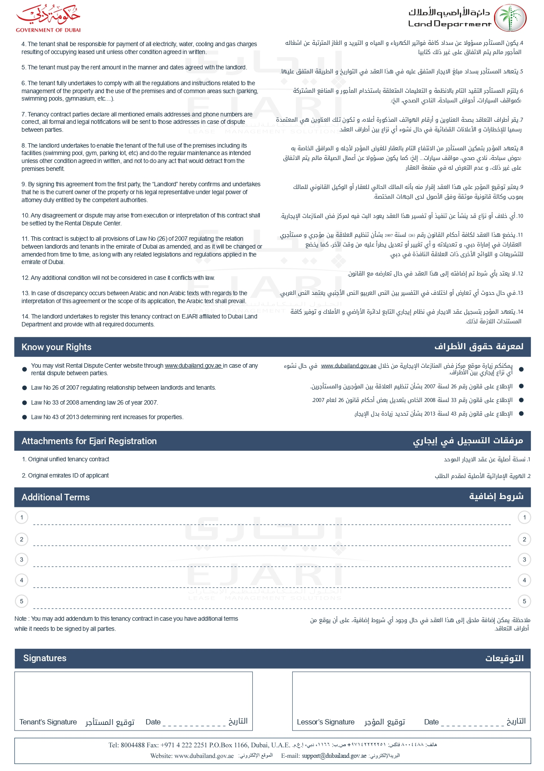

string terms 1